Topic: Application Software – Word
When I am done this lesson, I will know:
What Microsoft Office and Microsoft Word is
How to use some of the basic tools in Microsoft Word

Pre and Post Self-Assessment
 | Pre | Pre | Post | Post
 | Yes, I know this | No, I want to learn this | Yes, I know this | I still need more practice to learn this
I know what Microsoft Office is
I know how to use Microsoft Word


New Words and Terms

Microsoft Office
Microsoft Word
template
ribbon
font
document
save/save as

What is Microsoft Office?
Microsoft Office is a suite of software products developed by the Microsoft Corporation. It includes:
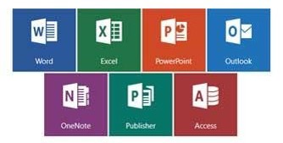
Word
Excel
Access
Publisher
PowerPoint
Outlook
OneNote
  Review | Software is a set of instructions or a computer program that tells the hardware what to do. The operating system of a computer is one type of software. There are also thousands of other types of software programs that you can use on a computer. Some of the most common software programs you might use are Microsoft Word or Adobe Acrobat. Software is written by a computer programmer.
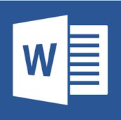
Microsoft Word
Microsoft Word is word processing software. We will be looking at some basic features in Microsoft Word 2016. Note: If you are using Microsoft 2013, there is a link for a tutorial at the end of this lesson.
To open Microsoft Word, open the start menu and select the Word menu item:
Once you open Word you will see the new window. This allows you to open a new Word document. You can choose a blank document or you can choose a template. A template is a document that has some formatting included to help get you started.
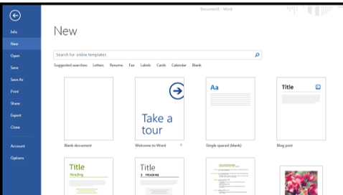
The Ribbon
The ribbon at the top of the page contains all the commands you need to do common tasks.
It has multiple tabs along the top. Each tab has several groups of commands.
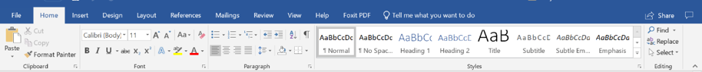
Backstage View
If you click on the FILE tab you will see the “backstage view.” Backstage view gives you options for saving, opening a file, printing, or sharing your document.
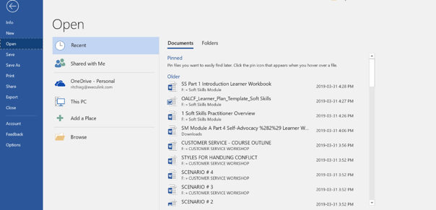
Typing in a Document
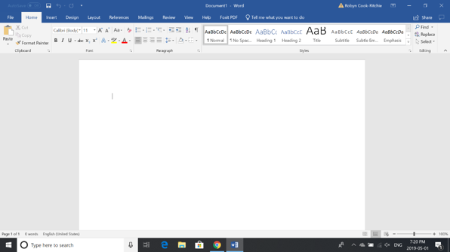
When you open a blank Word document it looks like this:

To insert text, use your mouse or touchpad to move the cursor to the spot on the page you want to start typing.
Click the mouse and the insertion point will show. The insertion point is a vertical line.
Start typing.
Deleting Text
- Place the insertion point next to the text you wish to delete.
- Press the Backspace key on your keyboard to delete text to the left of the insertion point.
- Press the Delete key on your keyboard to delete text to the right of the insertion point.
Selecting Text
- Place the insertion point next to the text you wish to select.
- Click the mouse (left button). While holding it down, drag your mouse over the text to select it.
- Release the mouse button.
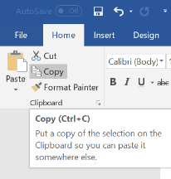
Copying and Pasting Text
- Select the text you want to copy.
- Click the Copy command on the Home tab.
- You can also right-click your document and select Copy.
- Place your insertion point where you want the text to appear.
- Click the Paste command on the Home tab.
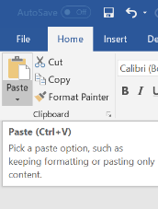
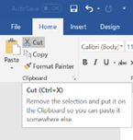
Cutting and Pasting Text
- Select the text you want to cut.
- Click the Cut command on the Home tab.
- You can also right-click your document and select Cut.
- Place your insertion point where you want the text to appear.
- Click the Paste command on the Home tab.

Try this/Practice
- Open an existing Word document.
- Select a sentence.
- Copy and paste the sentence from one location in the document to another.
- Select another sentence.
- Cut and paste the sentence to another location in the document.
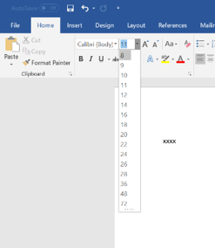
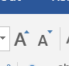
Font Size
- If you want to change the font size, select the text you want to change.
- Click the drop-down arrow next to the Font Size box on the Home tab.
- Select a font size.

You can also use the grow font and shrink font commands to change the size.
Changing Font Style
- Select the text you want to change.
- Click the drop-down arrow next to the Font box on the Home tab.
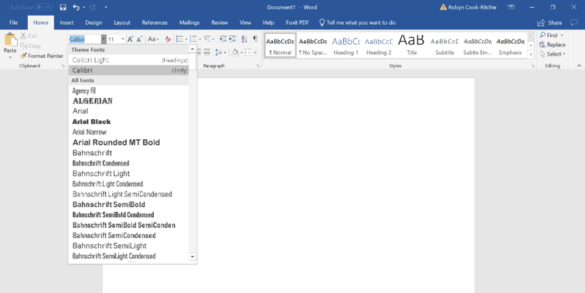
- Select a font.
Changing Font Colour
- Select the text you want to change.
- Click the Font Color drop-down arrow on the Home tab.
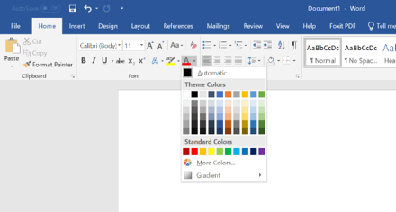
- Select a font colour.
Highlighting Text
- From the Home tab, click the Text Highlight Colour drop-down arrow.
- Select a highlight colour.
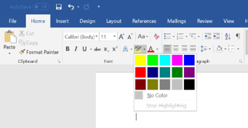
- Select the text you want to highlight.
Bold, Italic and Underline Commands
- Select the text you want to change.
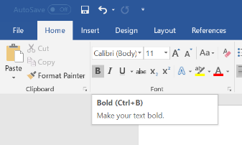
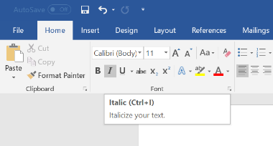
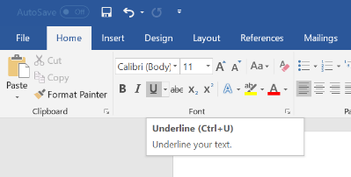
- Click the Bold (B), Italic (I), or Underline (U) command in the Font group on the Home tab.
Changing the Text Case
- Select the text you want to change.
- Click the Change Case command in the Font group on the Home tab.
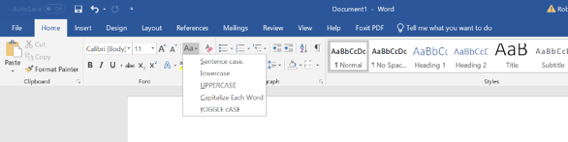
- Select a case option from the list.
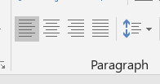
Changing Text Alignment
- Select the text you want to change.
- Select one of the four alignment options from the Paragraph group on the Home tab.

Align Text Left: Aligns all the selected text to the left margin.  Example: The dog chased the cat. | 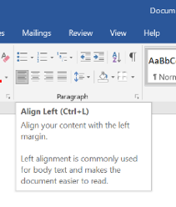
Center: Aligns text at equal distance from the left and right margins.  Example: The dog chased the cat. | 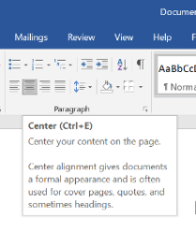
Align Text Right: Aligns all the selected text to the right margin.  Example: The dog chased the cat. | 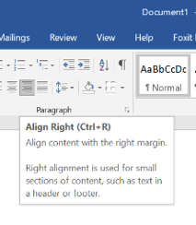
Justify: Justified text is equal on both sides and lines up equally to the right and left margins. | 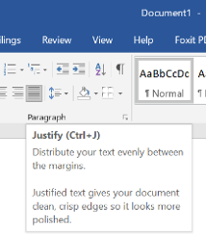
Try this/Practice
- Open an existing Word document.
- Change the font size of some text.
- Change the font style of some text.
- Change the font color of some text.
- Try various cases using the Change Case command.
- Try the four alignment commands.
Page Orientation
- Select the Layout tab.
- Click the Orientation command in the Page Setup group.
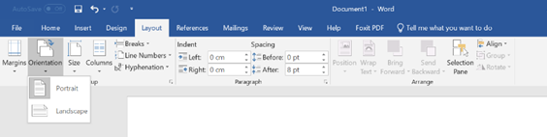
- Click either Portrait or Landscape to change the page orientation.
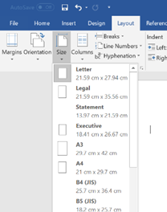
Page Size
- Select the Layout tab.
- Click the Size command and a drop-down menu will appear.
- Click a size option.
Formatting Page Margins
- Select the Page Layout tab.
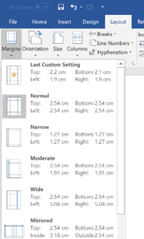
- Click the Margins command.
- A menu of options appears. Normal is selected by default.
- Click a margin size.
TRY THIS/PRACTICE
- Open an existing Word document.
- Change the page orientation.
- Change the paper size.
- Change the margins to Narrow.
- Adjust the margins using Custom Margins.
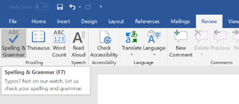
Spelling and Grammar
- Go to the Review tab.
Click on the Spelling & Grammar command.
When you click on the Spelling & Grammar command, the Spelling and Grammar dialog box will open at the right of your screen.
- For each error in your document, Word will try to offer suggestions.
- You can select a suggestion and then click Change to correct the error.
If no suggestions are given, you can type in the correct spelling.
Note: The spelling and grammar check is not always correct.
- There are errors that Word will not notice
- There are also times when the spelling and grammar check will say there is an error when there is not
If Word says that something is an error, you can choose not to change it
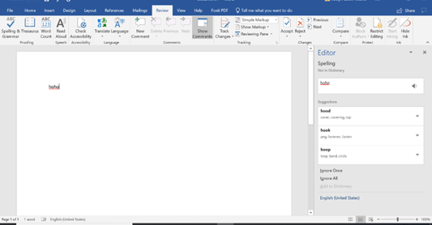
Depending on whether it’s a spelling or grammar error, you can choose from several options:
For spelling “errors”:
- Ignore Once: This will skip the word without changing it.
- Ignore All: This will skip the word without changing it, and it will also skip all other instances of this word in the document.
Add to Dictionary: This adds the word to the dictionary so that it will never come up as an error. Make sure that the word is spelled correctly before choosing this option.
For grammar “errors”:
- Ignore Once: This will skip the "error" without changing it.
- Ignore Rule: This will skip this "error" as well as all other instances that relate to this grammar rule.
Next Sentence: This skips the sentence without changing it, and leaves it marked as an error. That means it will still show up if you do another Spelling and Grammar check later on.
Word automatically checks your document for spelling and grammar errors, so you may not even need to run a separate Spelling and Grammar check. These errors are shown by coloured, wavy lines.
- The red line = misspelled word.
- The green line = grammar error.
- The blue line = contextual spelling error.
TRY this/Practice
- Open an existing Word document.
- Correct the spelling errors.
- Correct the grammar errors.

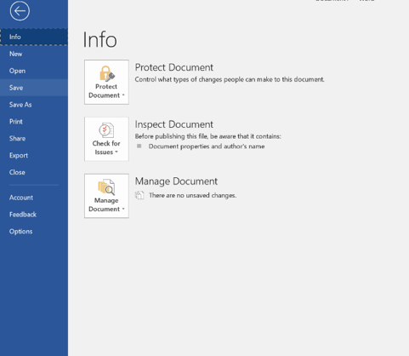
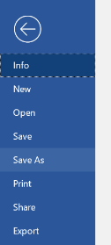
Saving Documents
- Click the File tab.
- Select Save.
- Follow the instructions to choose where you want to save the document.
Using the SAVE AS Command
The Save As command allows you to choose a name and location for your document. It’s useful if you want to save a different version of a document while keeping the original.
Printing Documents
- Click the File tab.
- Select Print.
- The Print pane appears, with the print settings on the left and the Preview on the right.
- Click on the Print button
- If you only want to print certain pages, you can type a range of pages. Otherwise, select Print All Pages.
- Select the number of copies.
- Click the Print button.
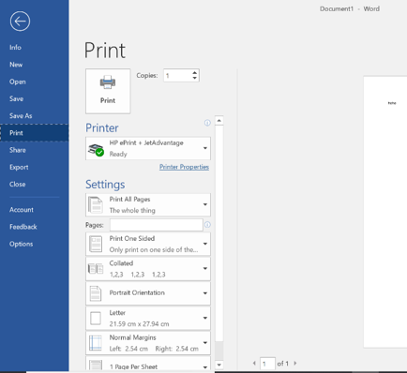

OPTIONAL: I WANT TO LEARN MORE
Complete a Word 2016 Tutorial here.  Source: GCFGlobal | https://edu.gcfglobal.org/en/word2016/

Complete a Word 2013 Tutorial here.  Source: GCFGlobal | https://edu.gcfglobal.org/en/word2013/


Ontario Adult Literacy Curriculum Framework Connection
Competency | Task Group(s)
Find and Use Information | Read Continuous Text (L2- point forms)  Interpret Documents (L3)  Extract Information from Films, Broadcasts and Presentations
Communicate Ideas and Information | Complete and Create Documents (L2 pre-post assessment)

Topic: Files and Folders
When I am done this lesson, I will know:
- What a file and a folder are
- Icons for common file types
- How to save a file in Windows
- How to create folders and organize files
- Some tips for saving and organizing files
Pre and Post Self-Assessment
 | Pre | Pre | Post | Post
 | Yes, I know this | No, I want to learn this | Yes, I know this | I still need more practice to learn this
I know what a file and a folder are
I know how to create folders and organize files

New Words and Terms

file
folder
PDF

What are Files and Folders?

